Evening dinner arrangements for CIB W62 (20/8/2024 – 22/08/2024) Northampton.

We have booked evening dinner reservations; Transport will be provided from Hilton & Marriot hotels and all meeting at Mercure Hotel for a short walk to the restaurant on Tuesday and Wednesday evening, but for those wishing to make their own way information is given below.

Tuesday 20th August @ 19.45
The Smoke Pit, 11A The Ridings, Northampton, NN1 2AQ
What3words: island.frame.crush
https://www.cowpigchicken.co.uk/

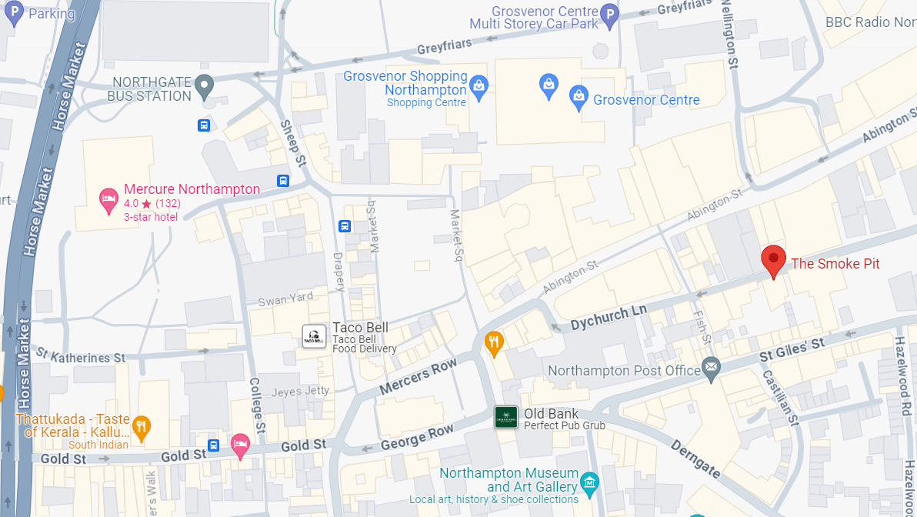

Wednesday 21st August @ 19.45
Chi, Sol Central Chi, Units 6a & 6b, Northampton NN1 1SR
What3words: hungry.spine.debate
https://www.chirestaurants.co.uk/chi-northampton

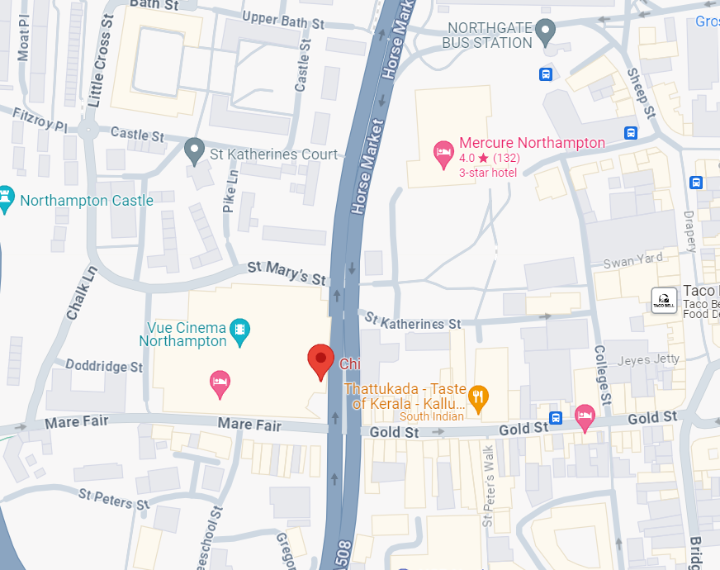

Thursday 22nd August Gala Dinner is only accessible by coach transport provided.
Pick up locations are from
Hilton Hotel @ 18.00
Marriot Hotel @ 18.00
Mercure Hotel @ 18.20

Return coaches from Gala dinner, coach 1 @ 23.00 & coach 2 @ 00.00 dropping at all 3 hotels.

